Diagonal Difference

First Algorithm: Non-Recursive Algorithm
1.Pseudo-code :
Algorithm DiagonalDifferenceIterative(matrix, n)
primarySum = 0
secondarySum = 0
For i from 0 to n - 1:
primarySum = primarySum + matrix[i][i]
secondarySum = secondarySum + matrix[i][n - 1 - i]
End For
Return AbsoluteValue(primarySum - secondarySum)

2.Implementation (C++):
#include <iostream>
#include <vector>
#include <cmath>
int diagonalDifferenceIterative(const std::vector<std::vector<int>>& matrix, int n) {
int primarySum = 0;
int secondarySum = 0;
for (int i = 0; i < n; i++) {
primarySum += matrix[i][i];
secondarySum += matrix[i][n - 1 - i];
}
return std::abs(primarySum - secondarySum);
}

3.Analysis & Complexity :
- Step-by-Step Analysis:
  - Initializes two sum variables: O(1).
  - Executes a loop n times where n is the number of rows/columns : O(n).
  - Performs two additions and index calculations per iteration : O(1).
  - Calculates the final absolute difference : O(1).
- Time Complexity : O(n) because we visit each row exactly once.
- Space Complexity : O(1) as we only store two integer sums regardless of matrix size.

4.Code (V.S) :

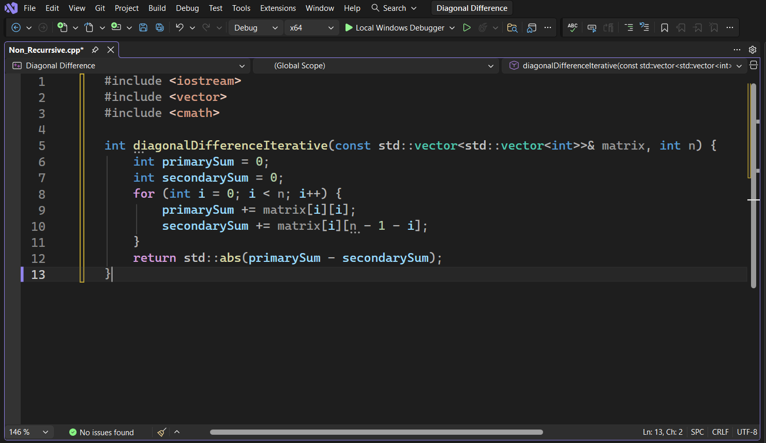

Second Algorithm: Recursive Algorithm :
1.Pseudo-code :
Algorithm RecursiveSum(matrix, n, i)
If i == n:
Return 0
currentDiff = matrix[i][i] - matrix[i][n - 1 - i]
Return currentDiff + RecursiveSum(matrix, n, i + 1)
Algorithm DiagonalDifferenceRecursive(matrix, n)
totalDiff = RecursiveSum(matrix, n, 0)
Return AbsoluteValue(totalDiff)

2.Implementation (C++) :
#include <iostream>
#include <vector>
#include <cmath>
int calculateRecursive(const std::vector<std::vector<int>>& matrix, int n, int i) {
if (i == n) return 0; // Base Case: all rows processed

int rowDiff = matrix[i][i] - matrix[i][n - 1 - i];
return rowDiff + calculateRecursive(matrix, n, i + 1);
}

int diagonalDifferenceRecursive(const std::vector<std::vector<int>>& matrix, int n) {
return std::abs(calculateRecursive(matrix, n, 0));
}

3.Analysis & Complexity
- Step-by-Step Analysis:
  - The function checks the base case (i == n): O(1).
  - Processes the current row's diagonal elements: O(1).
  - Makes a recursive call for the next row: n total calls.
- Time Complexity: O(n) as there are n recursive calls.
- Space Complexity: O(n) due to the recursion stack depth.

4.Code (V.S) :

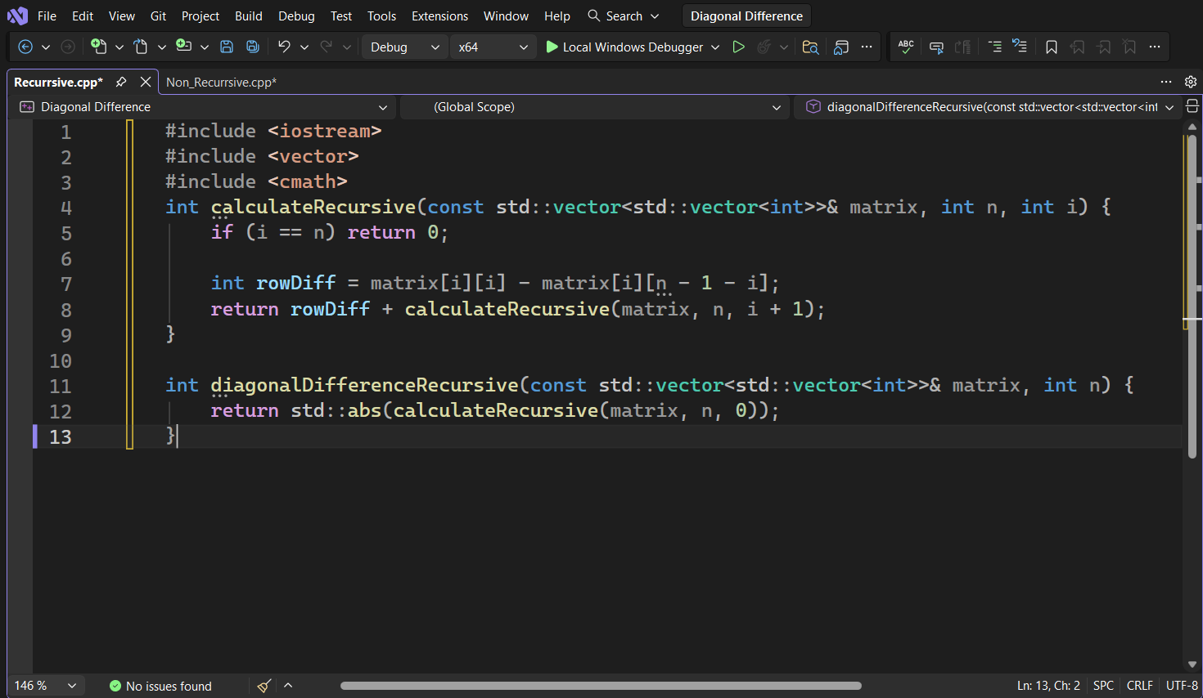

3. Comparison :
Feature | Non-Recursive | Recursive
Time Complexity | O(n) | O(n)
Space Complexity | O(1) | O(n)
Efficiency | Faster (no call overhead) | Slower (due to stack frames)
Readability | High for simple loops | High for mathematical definitions
When to Use | Large matrices | Small matrices

Recommendation: The non-recursive algorithm is preferred in practice. Since both approaches have the same time complexity O(n), the deciding factor is space. The iterative solution uses O(1) space, meaning memory usage stays constant regardless of matrix size. The recursive solution uses O(n) stack space, which can cause a stack overflow for very large matrices. Therefore, for any real-world application, the iterative approach is the better choice. The recursive approach is mainly useful for understanding the problem mathematically or in academic contexts where code clarity is prioritized over performance.

